

**A** **PROJECT REPORT**

**ON**

**ContactBook**

## Submitted in partial fulfillment for the Course of

**Database Management System Laboratory**

Submitted by:



| **S/L** | **Name** | **ID** |
| --- | --- | --- |
| **1** | **Tofayel Ahmed** | **201-15-3053** |
| **2** | **MD. Minhajul Hayat Mim** | **201-15-3557** |
| **3** | **Chonchal Khan** | **201-15-3071** |

Submitted to



| **Rubel Sheikh**  Lecturer  Department of Computer Science and Engineering Daffodil International University |
| --- |

**TABLE OF CONTENTS**

**ABSTRACT** 

1. **INTRODUCTION**

PROJECT AIMS AND OBJECTIVES

BACKGROUND OF PROJECT

SCOPE OF THE PROJECT

1. **SYSTEM ANALYSIS**

SOFTWARE REQUIREMENT SPECIFICATION

EXISTING VS PROPOSED

SOFTWARE TOOL USED

1. **SYSTEM DESIGN**

TABLE DESIGN

E-R DIAGRAM OF THE SYSTEM

1. **SYSTEM IMPLEMENTATION**

MODULE DESCRIPTION

SCREEN SHOTS

1. **SYSTEM TESTING**

UNIT TESTING

INTEGRATION TESTING

1. **CONCLUSION & FUTURE SCOPE**
2. **REFERENCES**

**CHAPTER 1**

**INTRODUCTION**

* 1. **PROJECT AIMS AND OBJECTIVES :**

Our Project Aim is building a robust Contact Book . This software will serve storing contact data . It is a web based application, so if any one lost his/her device that was never hampered . Our Contact Book stores all data in a cloud server . This is a cross platform software it can be used from any device through

browser .

* 1. **BACKGROUND OF THE PROJECT:**

Man is a social being ,so people need to communicate with each other . For communication contact details are important to handle personal life to business life . General contact software does not support cross platform features and cloud backup .

So , we are builded this project . This will serve a good service.

* 1. **SCOPE OF THE PROJECT:**

Our software is free and it does not contain any advertisement. It will run any kind of device which supports browser software . To use this

Software only needs the domain name of software .

This software does not support long description of contacts, it only supports email and phone numbers . To use this software you need a stable internet connection

**CHAPTER 1**

**System Analysis**

**SOFTWARE REQUIREMENT SPECIFICATION:** This software needs four fields Name, Address,Email ,Phone . It is required to create , update ,delete and edit contact information .

**EXISTING VS PROPOSED**: Existing System is not capable of storing data in cloud And required An application that installed in machine . So has a web based database and web based user interface .

**SOFTWARE TOOL USED:** Visual Studio code , Xampp, php programming language , chrome ,html,css , bootstrap.

**CHAPTER 3**

***TABLE DESIGN*** ***-***

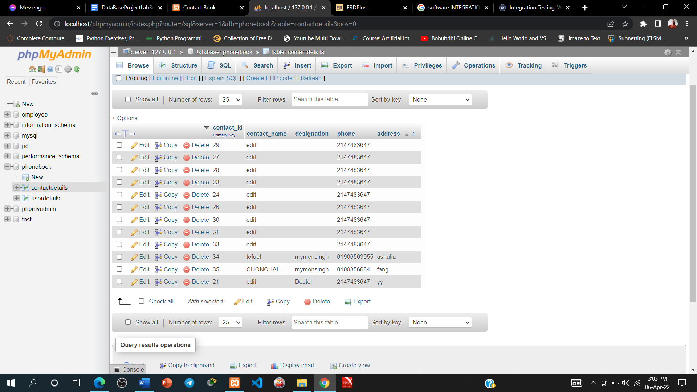

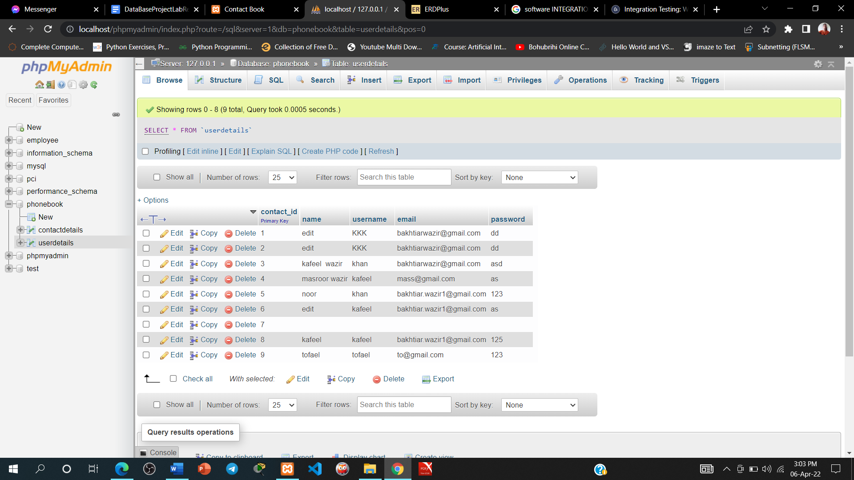

**SYSTEM DESIGN**

***Er Diagram:***

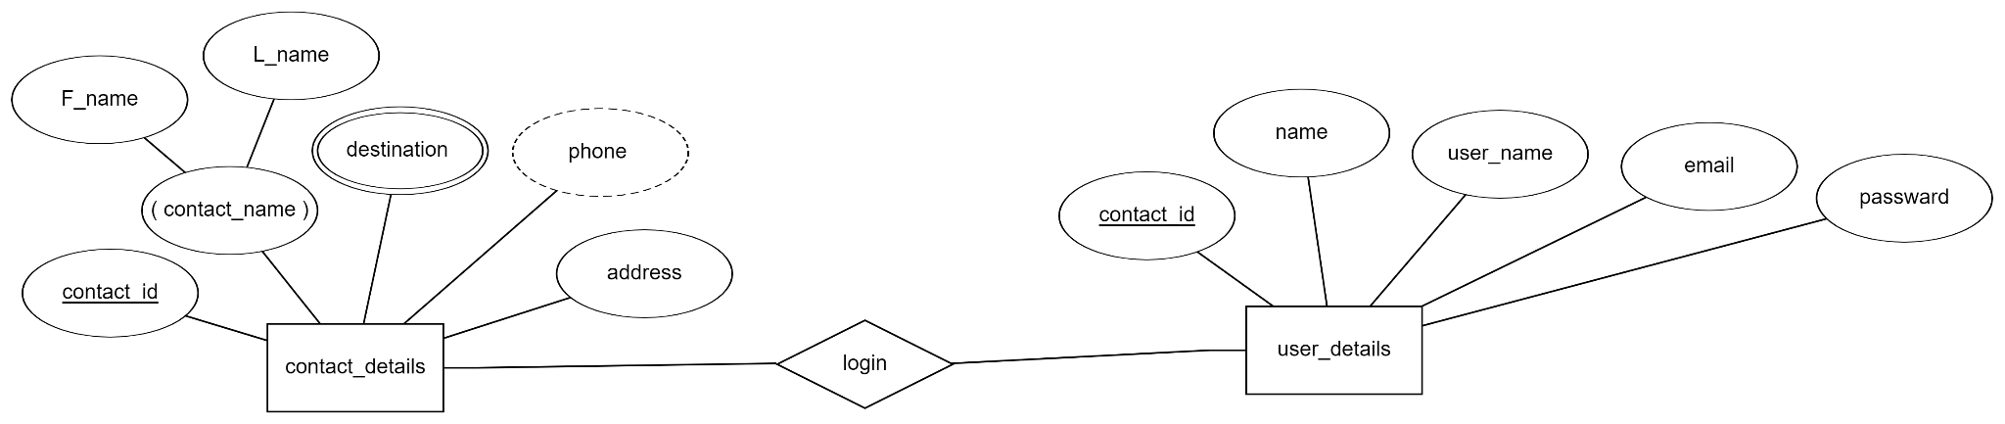

**CHAPTER 4**

**SYSTEM IMPLEMENTATION**

***MODULE DESCRIPTION***

**This software we use --**

**· PHP - PHP is a server scripting language, and a powerful tool for making dynamic and interactive Web pages.**

**· VISUAL STUDIO - Visual Studio Code is a code editor redefined and optimized for building and debugging modern web and cloud applications.**

**· XAMPP - XAMPP is a free and open-source cross-platform web server solution stack package developed by Apache Friends, consisting mainly of the Apache HTTP Server, MariaDB database, and interpreters for scripts written in the PHP and Perl programming languages.**

**· MY SQL SERVER - The MySQL server provides a database management system with querying and connectivity capabilities, as well as the ability to have excellent data structure and integration with many different platforms.**

**· CHROME BROWSER - The Google Chrome Web browser is based on the open source Chromium project.**

**· HTML - HTML stands for Hyper Text Markup Language · HTML is the standard markup language for creating Web pages ·**

**· CSS - CSS stands for Cascading Style Sheets · CSS describes how HTML elements are to be displayed on screen, paper, or in other media ·**

**· JAVA SCRIPT - JavaScript is the Programming Language for the Web. JavaScript can update and change both HTML and CSS.**

**SCREEN SHOTS**

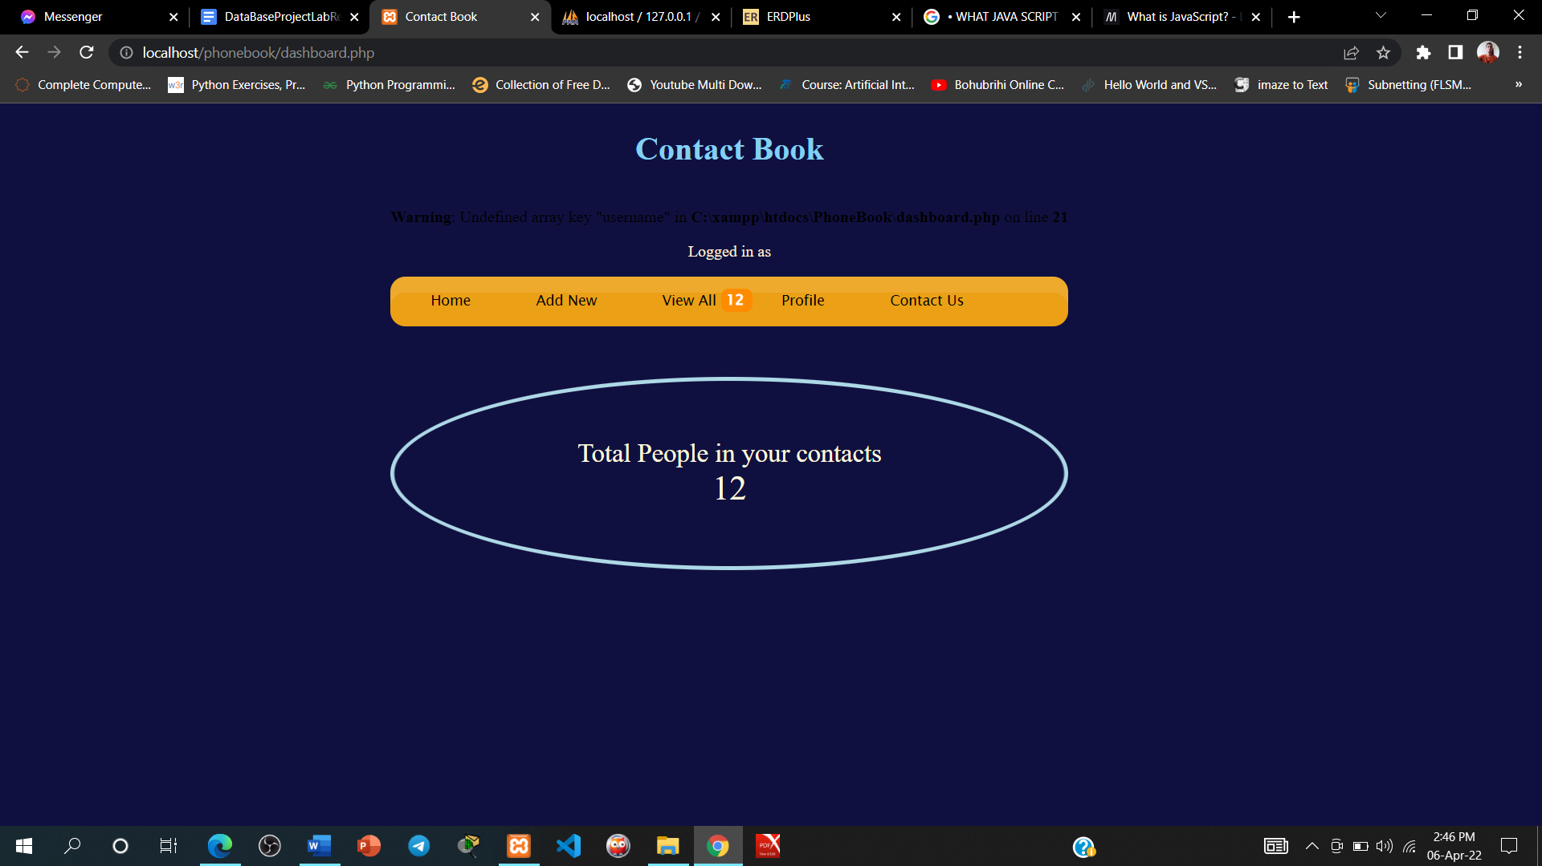

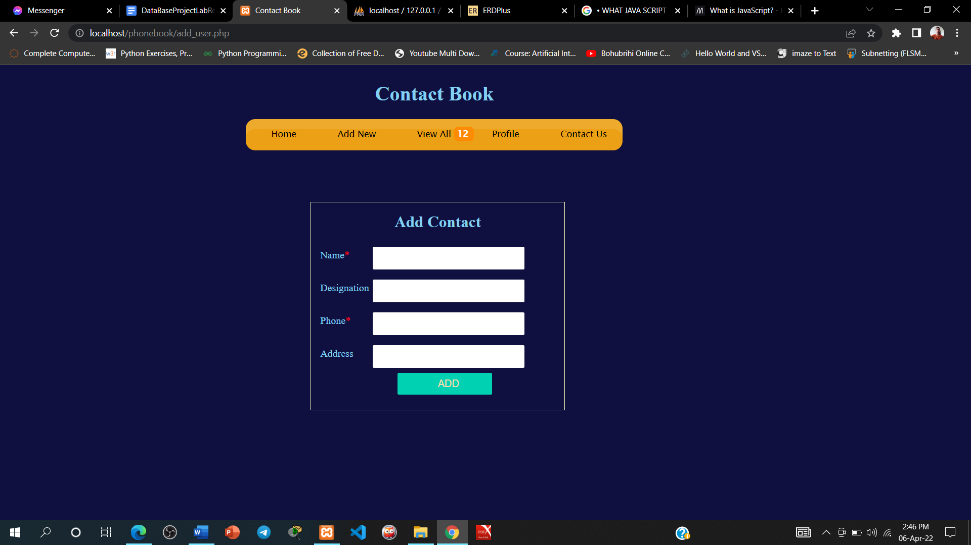

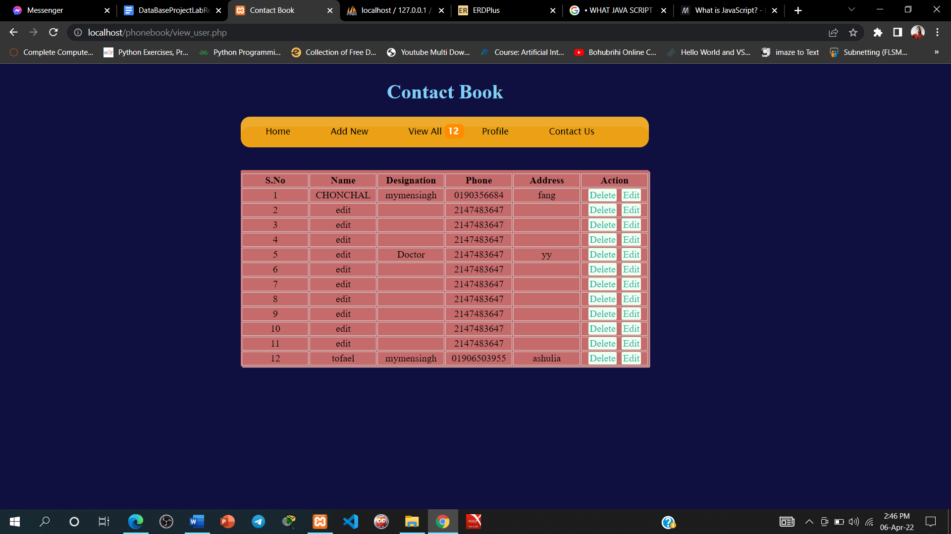

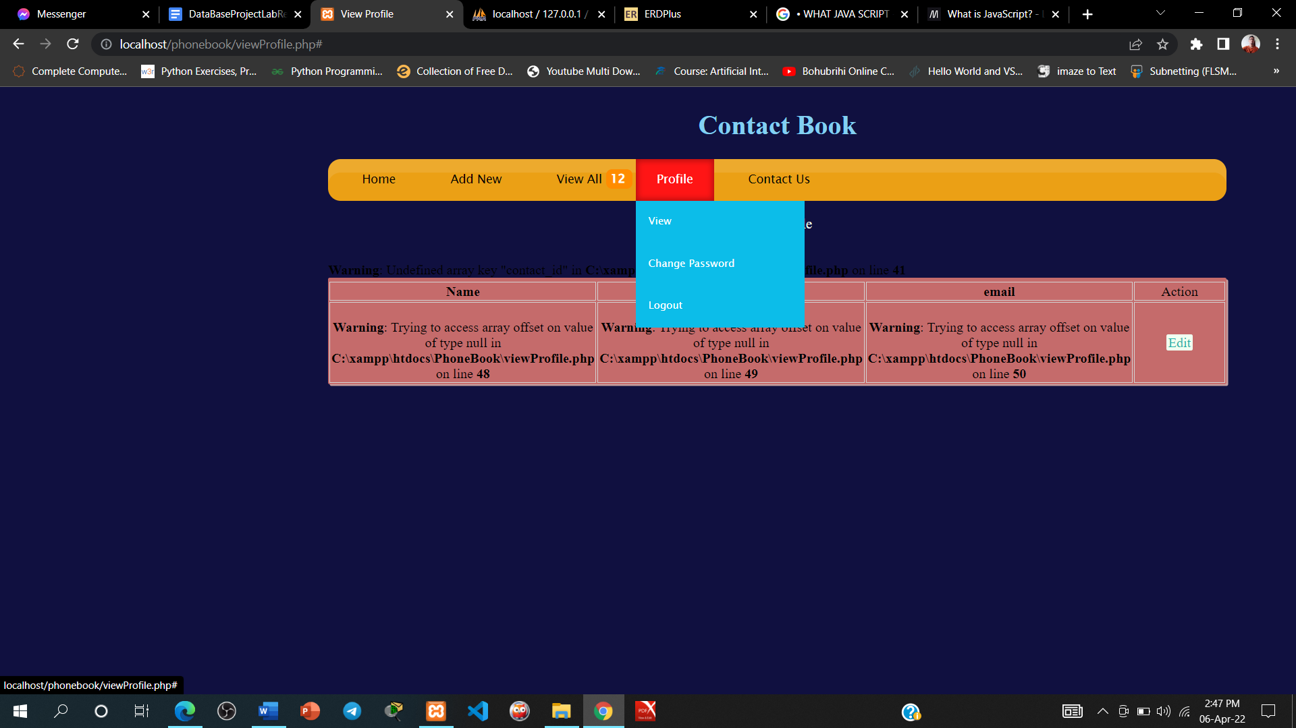

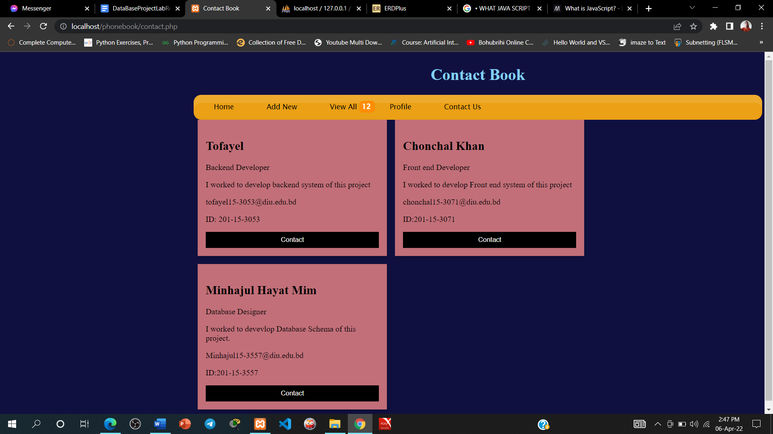

**CHAPTER 5**

**SYSTEM TESTING**

**UNIT TESTING**

**UNIT TESTING is a type of software testing where individual units or components of a software are tested. The purpose is to validate that each unit of the software code performs as expected. A unit may be an individual function, method, procedure, module, or object.**

**1. Unit tests help to fix bugs early in the development cycle and save costs.**

**2. It helps the developers to understand the testing code base and enables them to make changes quickly**

**3. Good unit tests serve as project documentation**

**4. Unit tests help with code re-use. Migrate both your code and your tests to your new project. Tweak the code until the tests run again.**

**We system manually testing and data entry , login, logout, home page, Add new , View all , Profile , Contact us .**

**INTEGRATION TESTING**

**INTEGRATION TESTING is defined as a type of testing where software modules are integrated logically and tested as a group. A typical software project consists of multiple software modules, coded by different programmers.**

* **A Module, in general, is designed by an individual software developer whose understanding and programming logic may differ from other programmers. Integration Testing becomes necessary to verify the software modules work in unity**
* **At the time of module development, there are wide chances of change in requirements by the clients. These new requirements may not be unit tested and hence system integration Testing becomes necessary.**
* **Interfaces of the software modules with the database could be erroneous**
* **External Hardware interfaces, if any, could be erroneous**
* **Inadequate exception handling could cause issues.**

**All feature are functionally used together.**

**CHAPTER 6**

**CONCLUSION AND FUTURE SCOPE**

Our Project is building a robust Contact Book . This software will serve storing contact data . It is a web based application, so if any one lost his/her device that was never hampered . Our Contact Book stores all data in a cloud server . This is a cross platform software it can be used from any device through

browser .

# High security,

# easy used.

#fast sloved problem for contact.

#expert employee all time monitor for service.

**CHAPTER 7**

**REFERENCES**

* **Google**